# Project 2

How to Create the new EC2 instance using AMI

Creating Images:

Steps:

1. To create image using AMI, go to EC2 and click on instances.
2. Select the instance that is created before and click on action.
3. In action, select image and template. In image and template, select create images.
4. Give name as anu-server-backup and description to the instances.

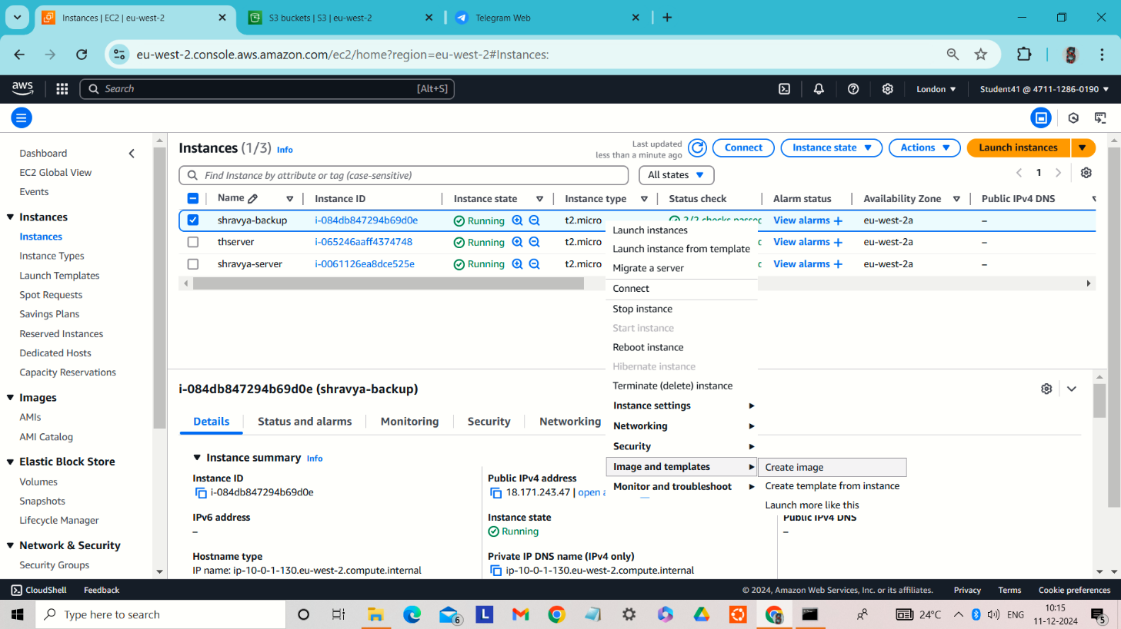

AMI summary:

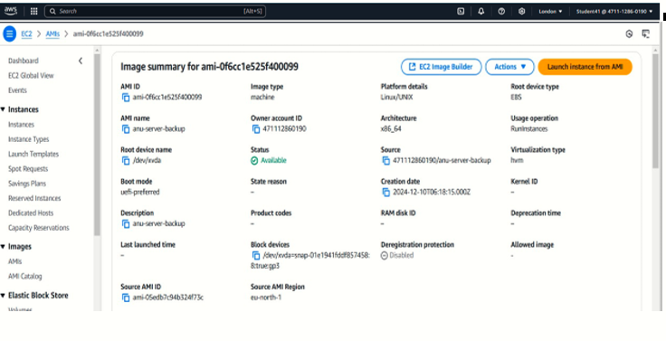

After launching the backup server :

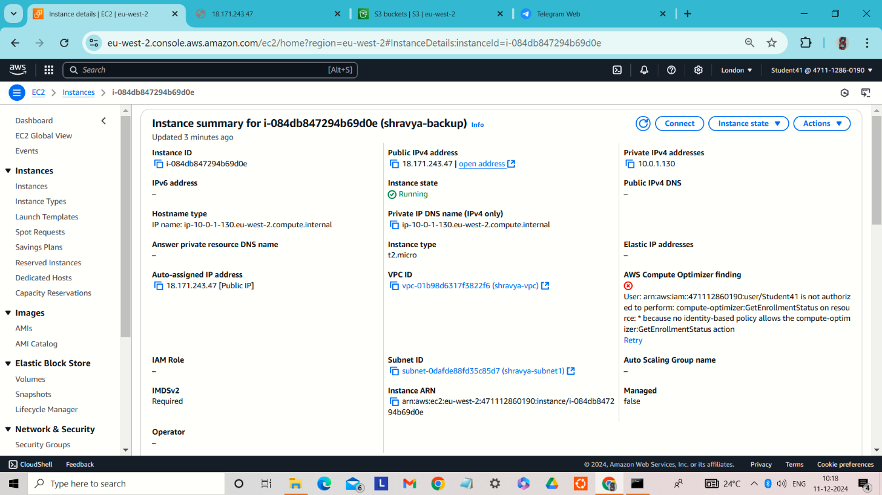

Final Result:

